Need a Ride to The Dalles?
541-296-7595
The Link Public Transit has a shuttle every Tuesday & Thursday serving Maupin, Wamic, Pine Hollow, Tygh Valley, & Dufur. We’ll take you into town and back!

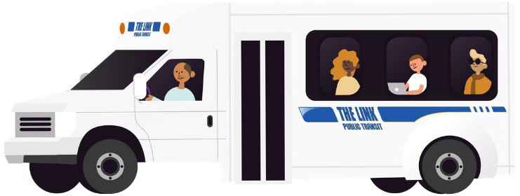

PICK-UPS Tuesday & Thursday Mornings at:
Maupin Market 8:00 AM
Maupin Country Store 8:01 AM
Canyon Rim Manor 8:05 AM Wamic Market & Supply 8:40 AM
Wamic Boat Ramp (Across Fire Department) 8:50 AM
Tygh Valley General Store 9:15 AM WE3 Coffee & Deli 9:45 AM
Please call ahead to book your ride in advance. We can also pick you up at your door anywhere within a half mile of the route. We’ll take you around The Dalles for shopping and appointments. Cost: $5 roundtrip from Maupin, Wamic, Pine Hollow, and Tygh Valley, $3 roundtrip from Dufur. 541-296-7595 for more information.

